Database programming evaluation

Task 1: Create three tables

CREATE TABLE DEPARTMENT(

department_id INT NOT NULL PRIMARY KEY,

Deptname VARCHAR(30),

deptLocation VARCHAR(20),

deptFloor VARCHAR(20)

);

CREATE TABLE EMPLOYEE

(

employee_id int NOT NULL,

Empname VARCHAR2(25),

Managerid INT,

Dateofhire DATE,

Jobname VARCHAR2(15),

Salary DECIMAL(10,2),

department_id INT,

DOB DATE,

address VARCHAR(30),

PRIMARY KEY (employee_id),

FOREIGN KEY (department_id) REFERENCES DEPARTMENT(department_id)

);

CREATE TABLE SALARY(

salary_level INT NOT NULL PRIMARY KEY,

salarymin INT,

salarymax INT

);

Task 2: Insert record of 10 employees in the employee table

INSERT INTO EMPLOYEE

VALUES ('1000','Nazrul','5095','2010-04-01','Manager', 100000.00,'2010','09-10-1980','12 Godfrey Avenue Sunshine North');

INSERT INTO EMPLOYEE

VALUES ('1001','Robert','1000','2011-04-02','Administrator', 60000.00,'2010','09-10-1990','12 Mary Street Sunshine East');

INSERT INTO EMPLOYEE

VALUES ('1002','Irfan','1000','2012-04-15','Administrator', 58000.00,'2010','01-08-1990','2 Lacy Street Ballarat Road');

INSERT INTO EMPLOYEE

VALUES ('1003','Akif','1000','2012-08-02','System Engineer', 57000.00,'2010','01-08-1992','13 Melon Street Braybrook');

INSERT INTO EMPLOYEE

VALUES ('1004','Zhoeb','1000','2014-06-08','System Engineer', 55000.00,'2010','15-05-1992','21 Albion Swanson Street');

INSERT INTO EMPLOYEE

VALUES ('1005','Flynn','5096','2010-07-01','Manager',

100000.00,'2011','04-08-1980','120/312 Queen Street Melbourne');

INSERT INTO EMPLOYEE

VALUES ('1006','Noman','1005','2012-06-02','Administrator', 60000.00,'2011','09-10-1991','4B Frankston Street Sunshine East');

INSERT INTO EMPLOYEE

VALUES ('1007','Naveen','1005','2013-06-01','Administrator',

60000.00,'2011','08-06-1991','3F Kings Park Street Sunshine');

INSERT INTO EMPLOYEE

VALUES ('1008','Srikanth','1005','2014-01-04','System Engineer', 55000.00,'2011','05-01-1992','22 Lacy Street Albion');

INSERT INTO EMPLOYEE

VALUES ('1009','Abdul','1005','2014-09-07','System Engineer', 55000.00,'2011','19-05-1993','423 Barkly Street West Footscray');

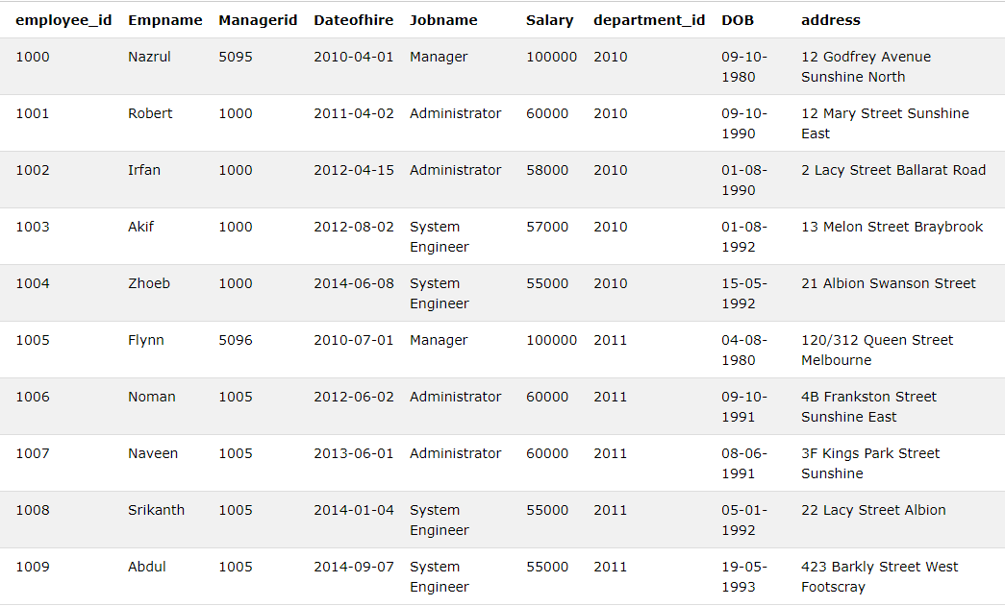

Task 3: Insert record of 5 departments in the department table

INSERT INTO DEPARTMENT

VALUES ('2007','Retail','Block 1','1');

INSERT INTO DEPARTMENT

VALUES ('2008','Sales','Block 2','2');

INSERT INTO DEPARTMENT

VALUES ('2009','Marketing','Block 2','3');

INSERT INTO DEPARTMENT

VALUES ('2010','Finance','Block 3','4');

INSERT INTO DEPARTMENT

VALUES ('2011','Information Technology','Block 4','5');

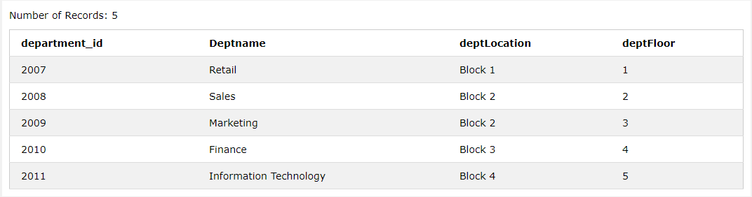

Task 4: Insert record of 5 salary levels in the salary table

INSERT INTO SALARY

VALUES ('1','95000','10000');

INSERT INTO SALARY

VALUES ('2','90000','95000');

INSERT INTO SALARY

VALUES ('3','75000','80000');

INSERT INTO SALARY

VALUES ('4','60000','75000');

INSERT INTO SALARY

VALUES ('5','55000','70000');

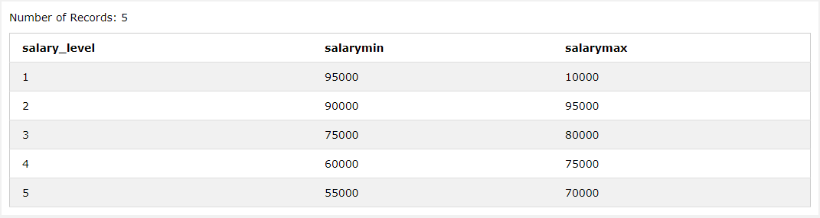

Task 5: Write a query to display the information about the employees in the employee table

SELECT * FROM EMPLOYEE

Task 6: Write a query to display the name of all the employees

SELECT Empname from EMPLOYEE

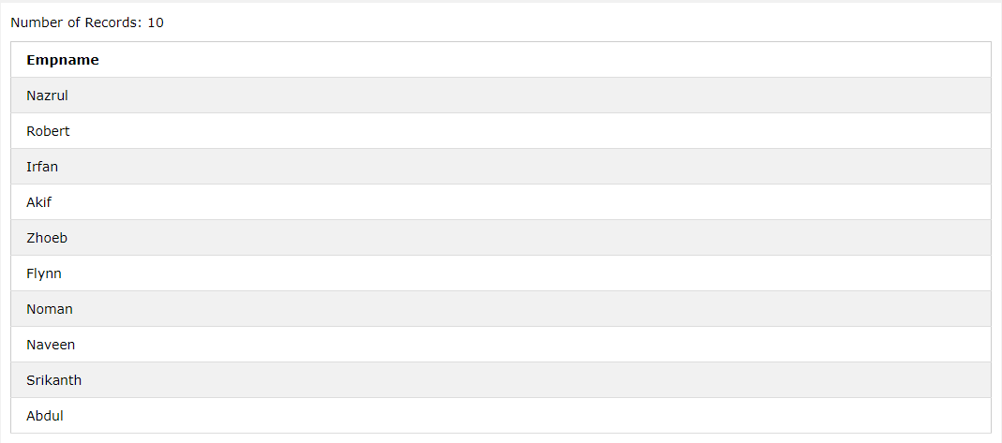

Task 7: Write a query to display the name of all the employees and their job name

SELECT Empname,Jobname FROM [EMPLOYEE]

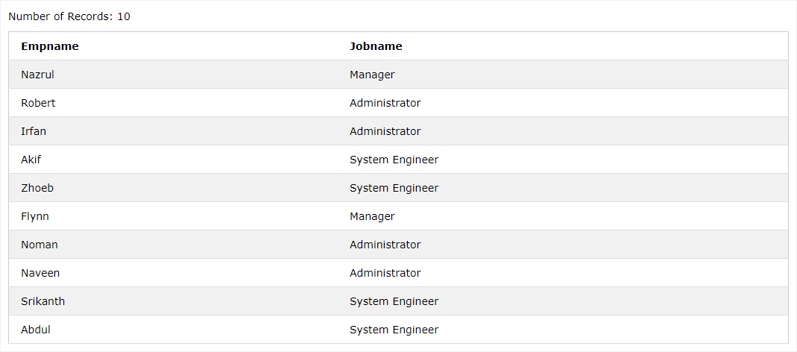

Task 8: Write a query in SQL to display the unique job name for all the employees

SELECT DISTINCT(Jobname) FROM [EMPLOYEE]

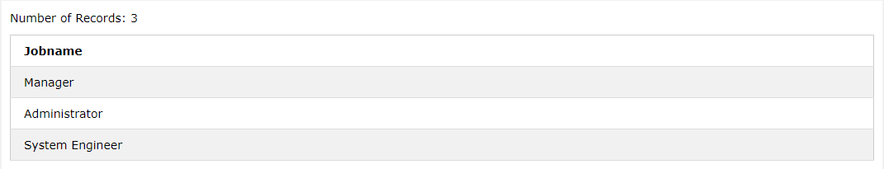

Task 9: Write a query to increase the salary for all the employees by 12%. Display the empname, jobname and salary after the increment.

UPDATE EMPLOYEE SET SALARY=SALARY+SALARY*0.12 WHERE department_id=2010

UPDATE EMPLOYEE SET SALARY=SALARY+SALARY*0.12 WHERE department_id=2011

SELECT Empname,Jobname,Salary FROM [EMPLOYEE]

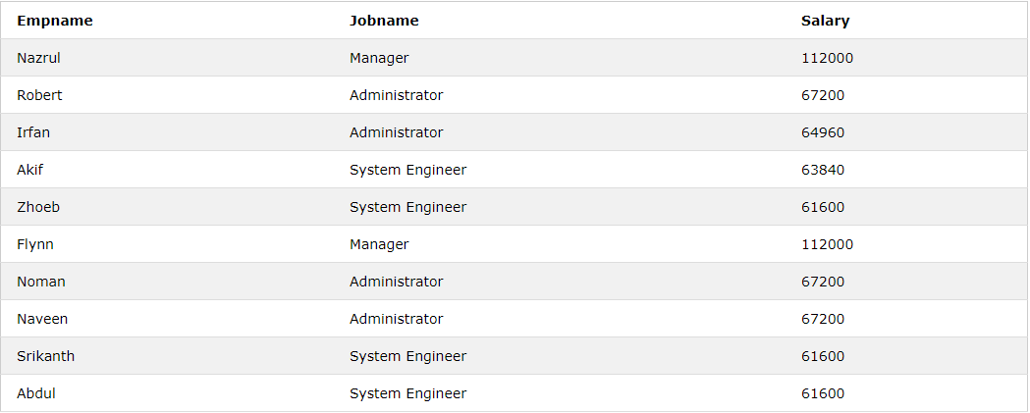

Task 10: Write a query to display the employee names with minimum and maximum salary.

SELECT MIN(Salary),Empname

FROM EMPLOYEE;

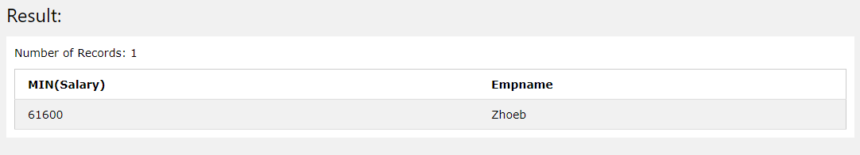

SELECT MAX(Salary),Empname

FROM EMPLOYEE;

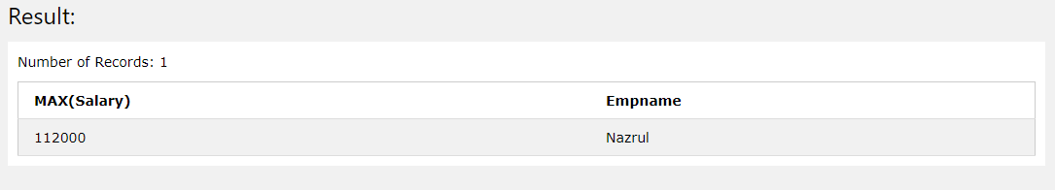

Task 11: Write a query to display the employee id, employee name, job name of all the employees whose salary is greater than 90,000 P.A.

SELECT Employee_id,Empname,Jobname FROM [EMPLOYEE]

WHERE Salary>90000

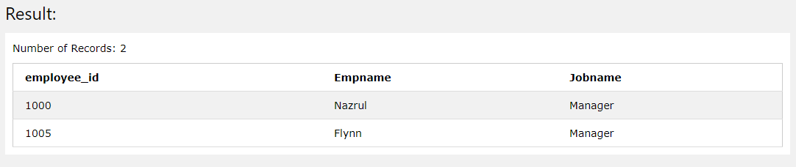

Task 12: write a query to display the all the details of all the employees whose job name are Manager.

SELECT * FROM [EMPLOYEE] WHERE Jobname='Manager'

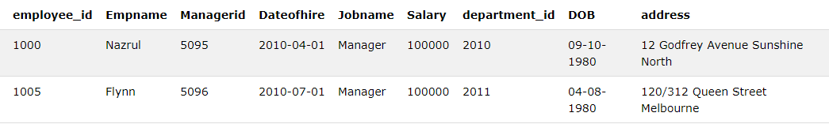

Task 13: Write a query to display the all the details of the employee whose name is Robert.

SELECT * FROM [EMPLOYEE] WHERE Empname='Robert'



Task 14: Write a query to display all the details of the employee who work as a manager and have salary greater than 95000 P.A.

SELECT * FROM [EMPLOYEE] WHERE Jobname='Manager' and Salary>95000

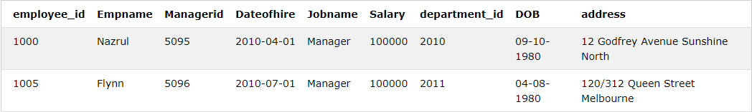

Task 15: Write a query to display employee id, employee name, job name and date of joining of all the employees who joined after year 2001

SELECT employee_id, Empname, Jobname,Dateofhire FROM [EMPLOYEE] WHERE Dateofhire > '2001-12-31'

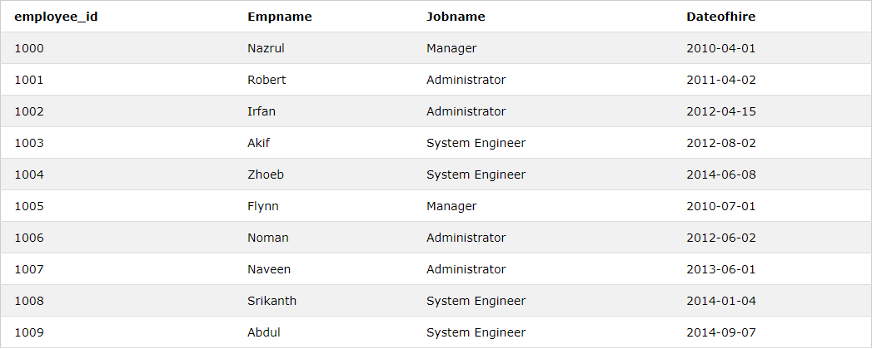

Task 16: Write a query to display the list of all the employees whose annual salary is within the range 55000and 95000.

SELECT Empname FROM [EMPLOYEE] where Salary BETWEEN 55000 and 95000

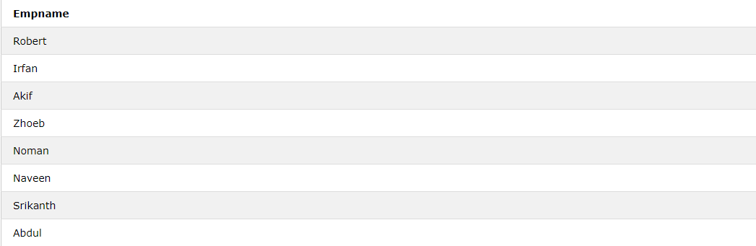

Task 17: Write a query to display the list of all the employees in the descending order of their salaries.

SELECT Empname FROM [EMPLOYEE] ORDER BY Salary DESC

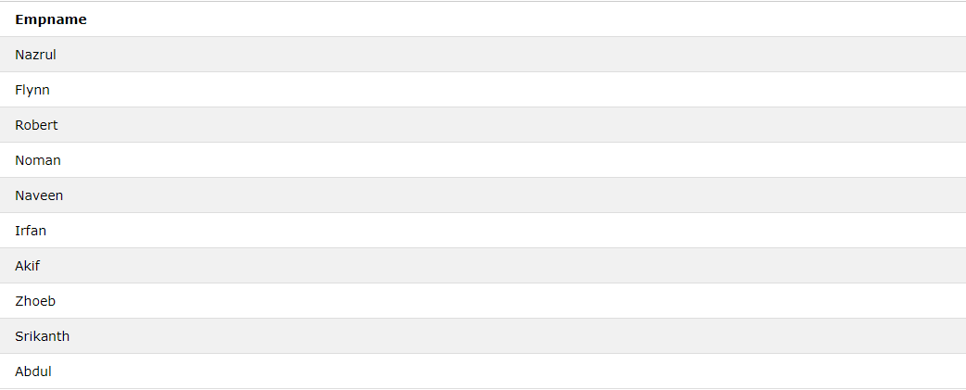

Task 18: Write a query to count the number of employees in the employee table

SELECT count(employee_id) FROM [EMPLOYEE]

Task 19: Insert a new record in the employee table and add ANALYST as their job name. The other fields can be added as per your choice.

INSERT INTO EMPLOYEE

VALUES ('1010','Tony Stark','1005','2014-01-09','Analyst','55000.00','2011','19-08-1992','841 batman hill victoria');

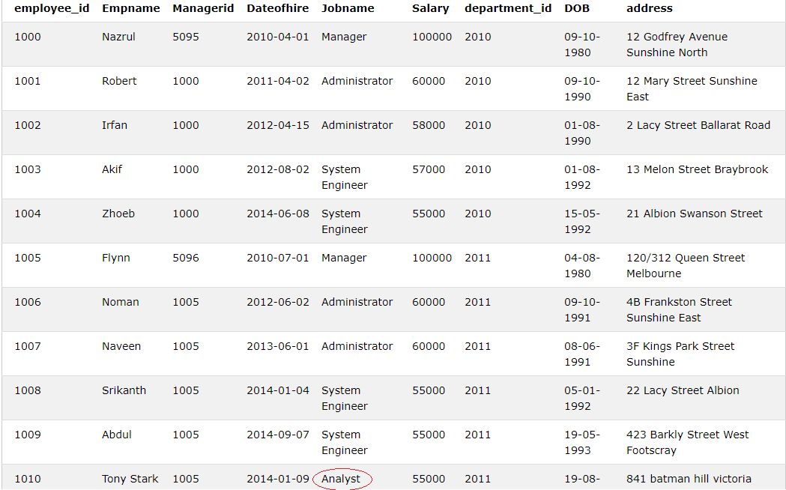

Task 20: Insert a new record in the employee table with the following data fields

INSERT INTO EMPLOYEE

VALUES ('1011','Janet','5095','2014-10-12','Programmer','90000.00','2011','19-12-1991','12B Mernda Street');

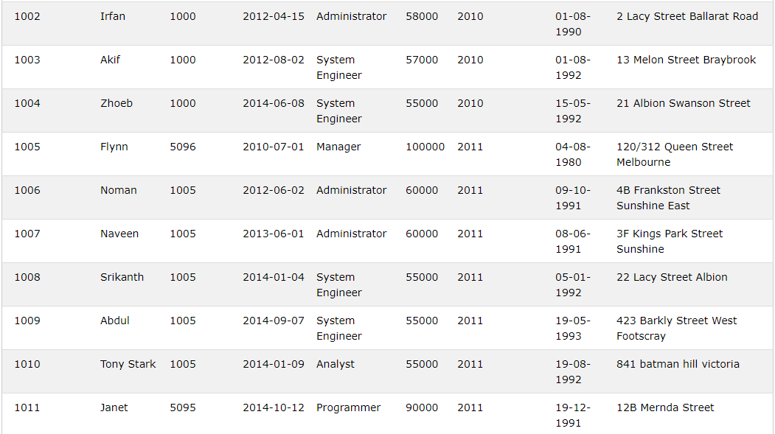

Task 21: Write a query to delete the record of the employee whose name is ‘Flynn’.

DELETE from EMPLOYEE WHERE Empname ='Flynn'

Task 22: Write a query to update the salary by 15% of the employee whose employee name is ROBERT.

UPDATE EMPLOYEE SET SALARY=SALARY+SALARY*0.15 WHERE Empname='Robert'

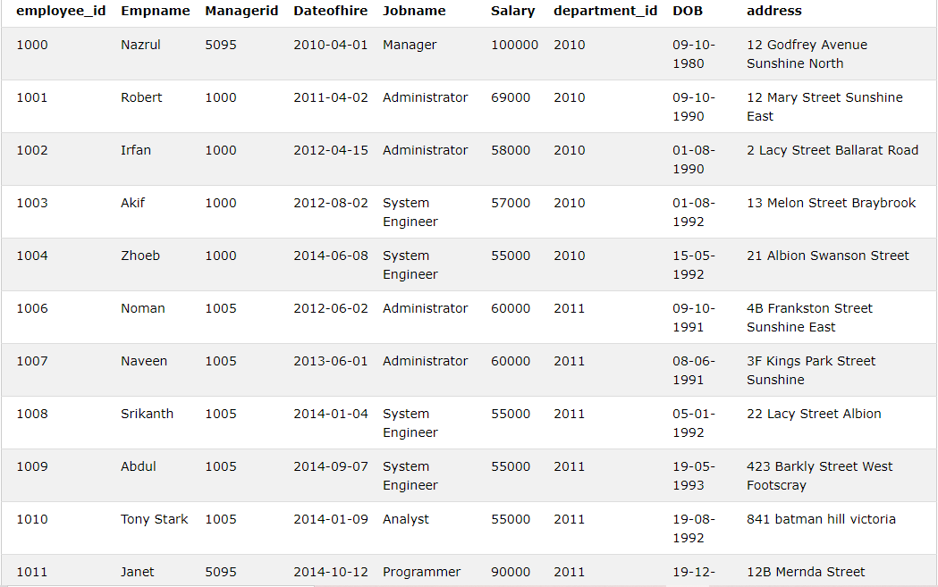

Task 23: Write a query to find the number of staff working in each department and the sum of their salaries.

SELECT COUNT(employee_id) FROM EMPLOYEE WHERE DEPARTMENT_ID=2010

SELECT SUM(SALARY) FROM EMPLOYEE WHERE DEPARTMENT_ID=2010

SELECT COUNT(employee_id) FROM EMPLOYEE WHERE DEPARTMENT_ID=2011

SELECT SUM(SALARY) FROM EMPLOYEE WHERE DEPARTMENT_ID=2011

Task 24: Write a query to find all employees with the string ‘Avenue’ in their address.

SELECT * FROM [EMPLOYEE] WHERE address like '%Avenue%'

